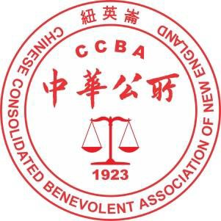
Chinese Consolidated Benevolent Association of New England

紐英崙中華公所

Presents the 53rd Annual Chinatown August Moon Festival
主辦第 53 屆華埠中秋節聯歡會
Sunday, August 13, 2023, 10:00 am – 5:00 pm
八月十三日星期日, 上午十時至下午五時
Boston Chinatown: Harrison Avenue and Beach, Tyler, Hudson, and Oxford Streets
波城華埠：夏利臣，必珠，泰勒，乞臣，及好士福街
August Moon Program Book Ad / Greetings
中秋場刊廣告 / 賀詞
Vendor Name 商戶名稱:

Address 地址:

Contact Person 聯絡人:

Cell # 手機號碼: Email Address 電郵地址:

 $500.00 Full page color Ad / Greetings (8.5 inch x 10.5 inch) 彩色全頁 (8 寸半 x 10.5 寸)
 $300.00 Full page Black and White Ad / Greetings (8.5 inch x 10.5 inch) 黑白全頁 (8 寸半 x 10.5 寸)
 $200.00 Half Page Black and White Ad / Greetings (8.5 inch x 5 inch) 黑白半頁 (8 寸半 x 5 寸)

Company name as it should appear on the ad. 公司名稱:

Greetings 賀詞:

Name on greetings 賀詞下款是:

Ad Submission Deadline: July 15, 2023 刊登廣告截止日期: 2023 年 7 月 15 日
For more information, please contact CCBA-NE at 617-542-2574 or felixkflui@gmail.com

資詢電話: 617-542-2574 或電信: felixkflui@gmail.com

